IAES Rocks and Minerals: Activity 22 “The Rock Cycle Game”
Absent Work

Key Words: No new words.

Getting Started:
1. Read the Introduction and Challenge to Activity 22, “The Rock Cycle Game,” in your Student Book on page B-44.

Procedure:
1. Carefully look at Student Sheet 22.1, “Geologist’s Notes.” During the activity, you will use this student sheet to keep track of what happens to your rocks and to explain how you gathered more rocks.

2. Look at the table below to prepare the materials you will need to complete the activity.

Materials Needed
Material | How to Prepare Material/  Where to Find Material
1 Rock Cycle Game Board | Attached to this packet
1 set of 30 Igneous Rock Cards | Attached to this packet. Cut out cards.
1 set of 30 Metamorphic Rock Cards | Attached to this packet. Cut out cards.
1 set of 30 Sedimentary Rock Cards | Attached to this packet. Cut out cards.
1 set of 9 Earth Process Cards | Attached to this packet. Cut out cards.
Game Pieces | Use any object that can serve as a game piece (coin, button, etc)
1 number cube | Attached to this packet. Cut out the number cube and fold on the dotted lines. Seal with tape.
2 Student Sheets 22.1, “Geologist’s Notes” | Attached to this packet.

3. Find a person to play the game with you. If you cannot find anyone, you can roll twice to represent two people playing. Give each player 9 Rock Cards: 3 Igneous Rock Cards, 3 Metamorphic Rock Cards, and 3 Sedimentary Rock Cards. Sort the remaining Rock Cards by rock type and place them on the game board in three separate stacks.

4. Place the Earth Process Cards face down on the game board in a single stack.

5. Place each person’s game piece on the Start space.

6. Begin by having each person roll the number cube. The person with the highest number should start the game.

7. The first person should toss the number cube and move that number of spaces on the game board. When someone lands on an Earth Process Space, he or she should pick up an Earth Process Card and follow the directions. After reading a card, replace it face down at the bottom of the stack.

8. Continue taking turns and playing the Rock Cycle Game. Remember, each person should record what happens to their rocks on Student Sheet 22.1. All new rocks should also be recorded on this sheet. An example is below.

Example:
Person A rolls a 3 and lands on “Wind breaks down rock into sediments. Lose 1 rock (any type).” Person A would choose one of their rocks (igneous, metamorphic, or sedimentary) to place back into the pile in the center of the board. If they choose to lose an igneous rock, they would record this on their Student Sheet 22.1:

What type of rock did you collect, lose, or exchange?
Igneous |  | Metamorphic |  | Sedimentary
What happened? | What caused the change? | What happened? | What caused the change? | What happened? | What caused the change?
Collected a new rock  Lost a rock  It became igneous  It became metamorphic  It became sedimentary | Rock broke down into sediments | Collected a new rock  Lost a rock  It became igneous  It became metamorphic  It became sedimentary |  | Collected a new rock  Lost a rock  It became igneous  It became metamorphic  It became sedimentary

9. Stop playing when the second person crosses the Start space again.

10. Answer Analysis Questions 1-5.

Analysis Questions:
1. How do igneous rocks form? Hint: On Student Sheet 22.1, look at what caused you to collect a new igneous rock or caused some rocks to become igneous. Combine your results with other members of your group.

______________________________________________________________________________________________________________________

______________________________________________________________________________________________________________________

______________________________________________________________________________________________________________________

2. How do sedimentary rocks form? Hint: On Student Sheet 22.1, look at what caused you to collect a new sedimentary rock or caused some rocks to become sedimentary. Combine your results with other members of your group.

______________________________________________________________________________________________________________________

______________________________________________________________________________________________________________________

______________________________________________________________________________________________________________________

3. How do metamorphic rocks form? Hint: On Student Sheet 22.1, look at what caused you to collect a new metamorphic rock or caused some rocks to become metamorphic. Combine your results with other members of your group.

______________________________________________________________________________________________________________________

______________________________________________________________________________________________________________________

______________________________________________________________________________________________________________________

4. Look at the three rock type columns on Student Sheet 22.1. Identify the types of rocks that can become:
a. igneous
b. sedimentary
c. metamorphic

______________________________________________________________________________________________________________________

______________________________________________________________________________________________________________________

______________________________________________________________________________________________________________________

______________________________________________________________________________________________________________________

______________________________________________________________________________________________________________________

______________________________________________________________________________________________________________________

5. Make a list of the forces that caused rocks to change from one type to another. Hint: On Student Sheet 22.1, look at what caused you to lose rocks. Combine your results with the other members of your group.

______________________________________________________________________________________________________________________

______________________________________________________________________________________________________________________

______________________________________________________________________________________________________________________

6. Create a diagram using words and arrows to describe the relationship between igneous, sedimentary, and metamorphic rocks.

7. Where do rocks come from? Explain your answer.

______________________________________________________________________________________________________________________

______________________________________________________________________________________________________________________

______________________________________________________________________________________________________________________

______________________________________________________________________________________________________________________

______________________________________________________________________________________________________________________

______________________________________________________________________________________________________________________

______________________________________________________________________________________________________________________

______________________________________________________________________________________________________________________

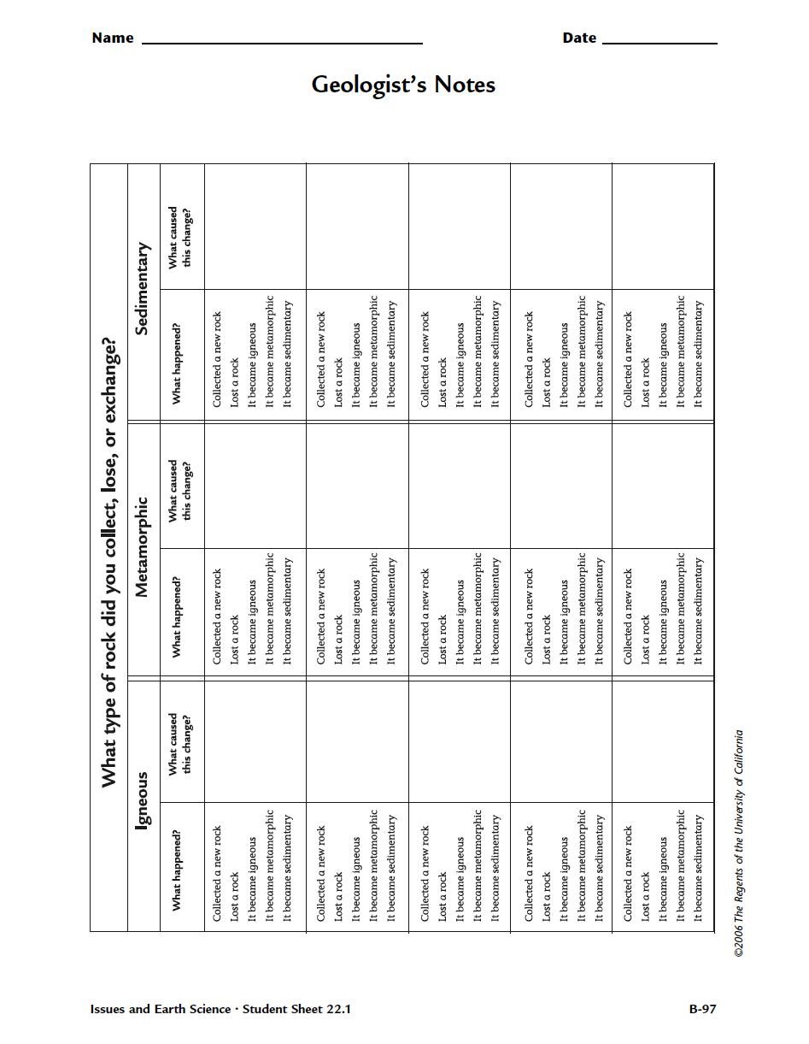

Earth Process Cards
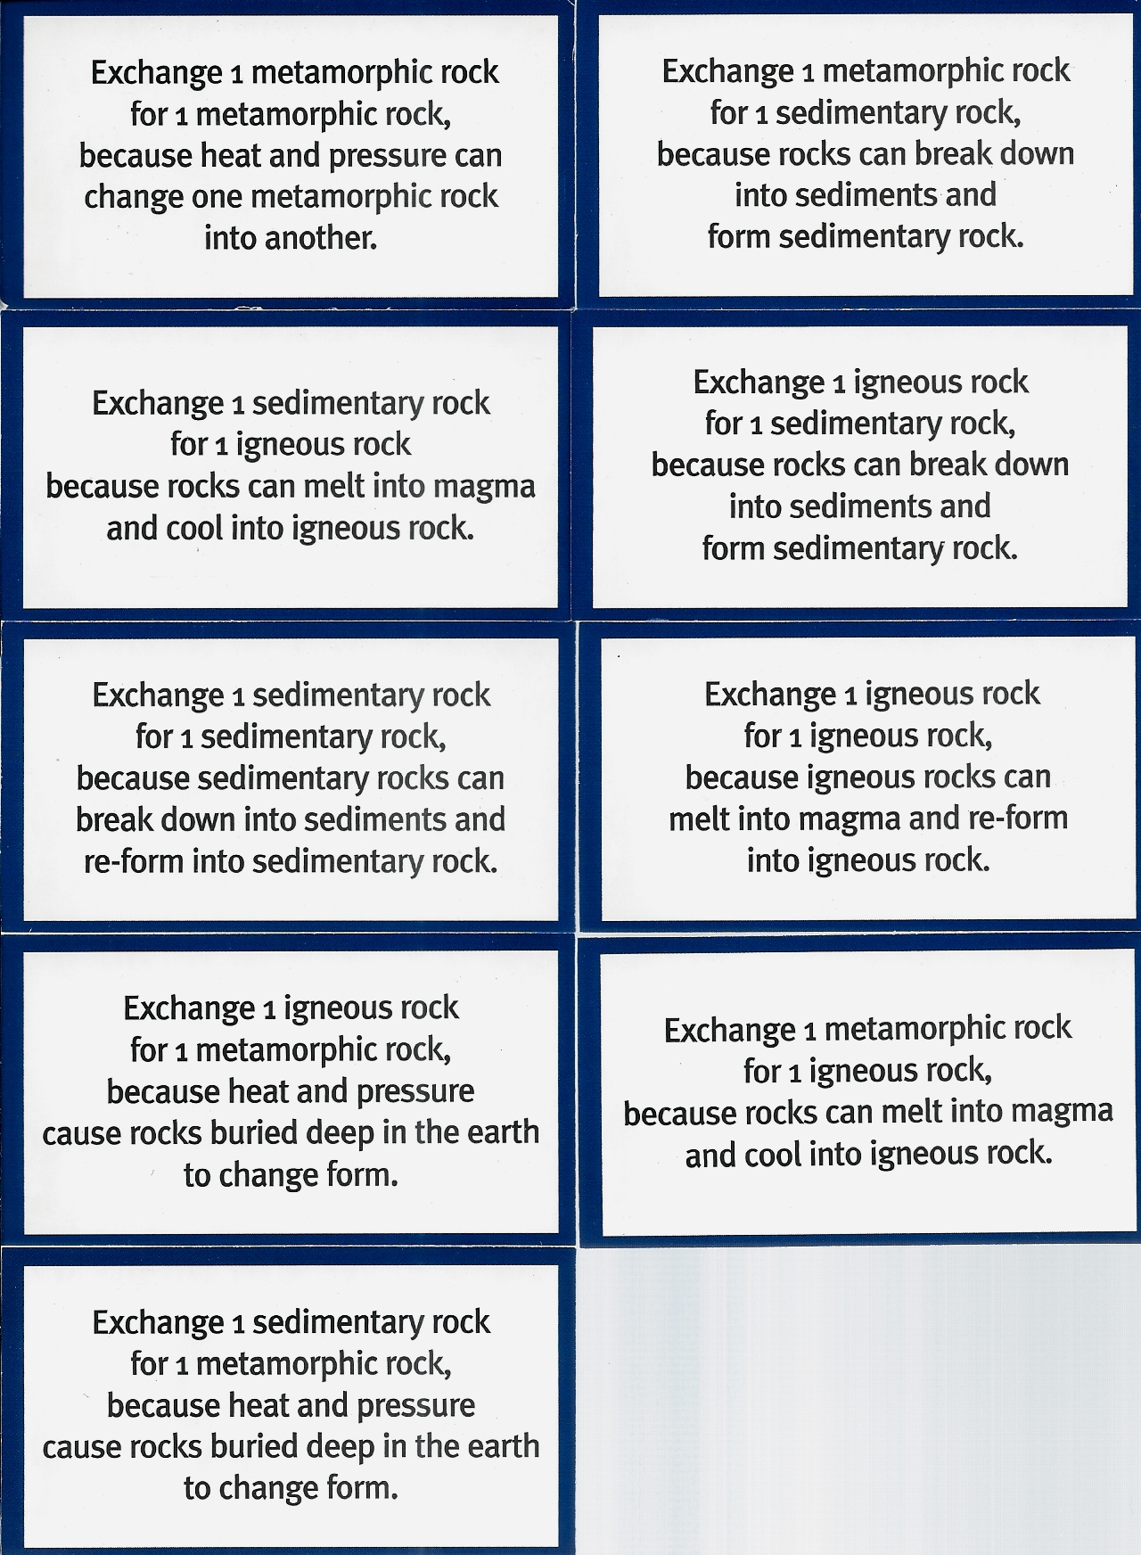

Igneous | Igneous
Igneous | Igneous
Igneous | Igneous
Igneous | Igneous
Igneous | Igneous
Igneous | Igneous
Igneous | Igneous
Igneous | Igneous
Igneous | Igneous
Igneous | Igneous

Igneous | Igneous
Igneous | Igneous
Igneous | Igneous
Igneous | Igneous
Igneous | Igneous
Sedimentary | Sedimentary
Sedimentary | Sedimentary
Sedimentary | Sedimentary
Sedimentary | Sedimentary
Sedimentary | Sedimentary

Sedimentary | Sedimentary
Sedimentary | Sedimentary
Sedimentary | Sedimentary
Sedimentary | Sedimentary
Sedimentary | Sedimentary
Sedimentary | Sedimentary
Sedimentary | Sedimentary
Sedimentary | Sedimentary
Sedimentary | Sedimentary
Sedimentary | Sedimentary

Metamorphic | Metamorphic
Metamorphic | Metamorphic
Metamorphic | Metamorphic
Metamorphic | Metamorphic
Metamorphic | Metamorphic
Metamorphic | Metamorphic
Metamorphic | Metamorphic
Metamorphic | Metamorphic
Metamorphic | Metamorphic
Metamorphic | Metamorphic

Metamorphic | Metamorphic
Metamorphic | Metamorphic
Metamorphic | Metamorphic
Metamorphic | Metamorphic
Metamorphic | Metamorphic

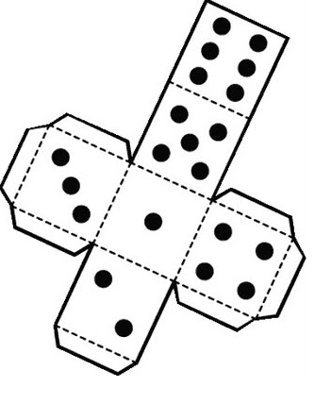

Sediments stick together. Collect 1 sedimentary rock. | Earth Process Card | A volcano erupts and magma cools. Collect 1 igneous rock. | Earth Process Card | Most rocks form slowly. Lose 1 turn while you wait. | Rocks deep in the earth can melt into magma. Lose 2 rocks (any type).
Rocks inside the earth melt into magma. Lose 1 rock (any type). | Earth Process Cards  Igneous  Sedimentary  Metamorphic  The Rock Cycle Game |  |  |  | Sediments press together. Collect 1 sedimentary rock.
Magma cools deep in the earth. Collect 1 igneous rock. |  |  |  |  | Earth Process Card
Earth Process Rock |  |  |  |  | Heavy floods move rocks. Slide forward 5 spaces.
Rain breaks down rocks into sediments. Lose 1 rock (any type). |  |  |  |  | Wind breaks down rocks into sediments. Lose 1 rock (any type).
START |  |  |  |  | Earth Process Card
A volcano erupts…Slide forward 5 spaces |  |  |  |  | Sediments stick together. Collect 1 sedimentary rock.
Earth Process Card |  |  |  |  | Earth Process Card
Wind breaks down rocks into sediments. Lose 1 rock (any type). |  |  |  |  | Magma cools deep in the earth. Collect 1 igneous rock.
Sediments press together. Collect 1 sedimentary rock, | Erosion! Lose 1 rock of each type. | …and magma cools. Collect 1 igneous rock. | Earth Process Card | Rain breaks down rocks into sediments. Lose 1 rock (any type). | Earth Process Card

